Name: ____________________________________ Date: ___________________________ Period: _______

Major Belief Systems in Our World

Belief System | Mainly Located in… | Monotheistic or Polytheistic? | Basic Belief | Rituals | Sacred Places, texts, objects and symbols | Belief in Afterlife
Christianity
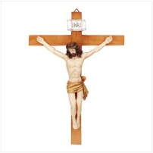
Judaism
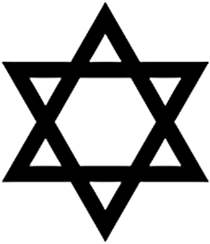
Islam
Belief System | Mainly Located in… | Monotheistic or Polytheistic? | Basic Belief | Rituals | Sacred Places, texts, objects and symbols | Belief in Afterlife
Hinduism
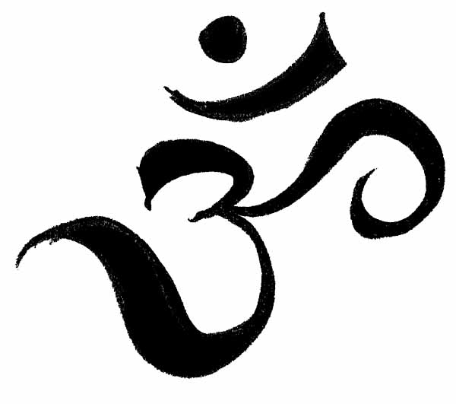
Buddhism
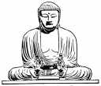
Taoism
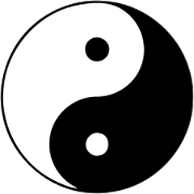
Sikhism
