World History Spark
Write the spark number, title, and prompt. Then respond to the prompt in 3-5 sentences.

Sp2: “Celebration of Marriage”
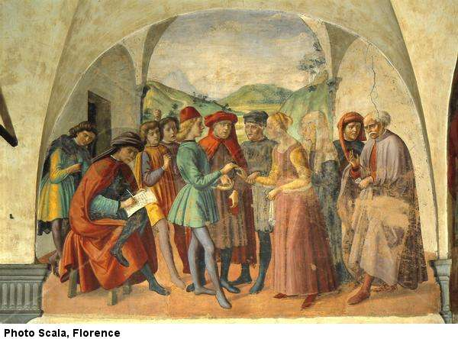
During the Renaissance, a marriage was more of a business arrangement than a matter of love. How does this painting (Celebration of Marriage by Ghirlandaio Domenico) support or contradict this statement?

