Name: _______________________________
Date: ________________________________
Period: _____
The West

I. Available Water
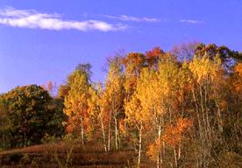
A. Natural vegetation in dry areas of the West (ex: San Diego, Reno)
1. Short grasses
2. Shrubs
3. Sagebrush
4. Cactus
B. Natural vegetation in areas with adequate rainfall (ex: Seattle)
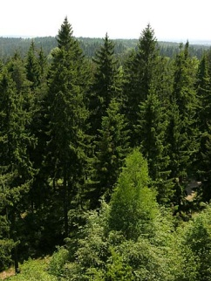
1. Deciduous trees
2. Coniferous trees
C. Hawaii
1. Wet, tropical climate
2. Rainforest
D. Alaska
1. Tundra – a dry, treeless plain that sprouts grasses and mosses only in summer, when the top layer of soil thaws

II. Natural Resources and the Economy
A. Minerals beneath mountains
1. Gold, silver, uranium, copper, tin, etc.
2. Mid-1800’s Gold Rush –
a. Huge mining companies were successful
b. Many individual prospectors came also and were not as lucky
c. Still, people were drawn to the west by rumors of others “striking it big” (Comstock Lode)
d. Businesses also came to provide services to miners
B. Natural gas and oil
1. Alaska’s entire economy changed after discovery of oil field at Prudhoe Bay
2. Alaska Pipeline – carries oil that has not been processed across the tundra
C. Forestry and Fishing
1. Half the lumber for construction in the US comes from the Pacific Northwest
2. Fish caught bring in billions of dollars from all over the world

III. Growth of Western Cities
A. Transcontinental railroad spurs growth along it
B. People always preferred living in cities out west because of countryside’s harsh climate and landscape
C. Los Angeles = second largest city in nation
1. LA must use aqueducts to support population
2. Aqueducts are large pipes that carry water over large distances
Remote – Far away, distant
IV. Conquering Western Distances
A. Alaska – largest state but least populated, remote
1. Few roads through the mountains
2. Juneau, state capital, can only be reached by boat or airplane
B. Hawaii – eight main islands (over 100 smaller islands) in the Pacific Ocean
1. 1898 US annexed Hawaii, 1959 Hawaii becomes 50th state
Annex – to incorporate a country or territory within another nation
2. US wanted Hawaii in order to use it as a refueling station for navy ships
3. Popular tourist destination (courtesy of jet planes)

Answer the following questions in your notes:
1. What are three major industries in the West that rely most directly on natural resources?

2. What geographic features have influenced where people live in the West?

3. What might be the consequences of continued population growth in the West?

