Native American Pipeline Protest Halts Construction in N. Dakota
Construction halted after more than 1,000 people swarm to protest the Dakota Access pipeline they believe threatens the Missouri River. Phil McKenna 8/19/2016
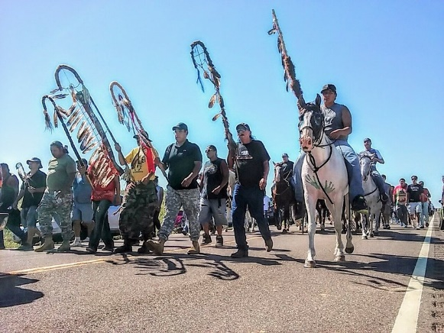
Native American protesters succeeded in halting construction of the Dakota Access pipeline near Cannon Ball, N.D.

A groundswell of Native American activists has temporarily shut down construction on a major new oil pipeline with an ongoing protest that has drawn around 1,200 people to Cannon Ball, N.D.
Construction workers walked away from their bulldozers Monday after protesters surrounded the equipment and called for an end to construction of the Dakota Access pipeline. A group of protesters on horseback also staged a mock charge toward a line of law enforcement officials guarding the site, and the county sheriff alleged others have fired guns and set off pipe bombs.
The $3.8 billion pipeline at the heart of the protest would carry about half a million barrels of crude oil per day from the Bakken oil field to Illinois where it would link with other pipelines to transport the oil to Gulf Coast refineries and terminals.
The protest was staged at a spot where the pipeline would pass beneath the Missouri River, just upstream from the Standing Rock Sioux reservation, a community of 8,500 along the Missouri River in North and South Dakota.
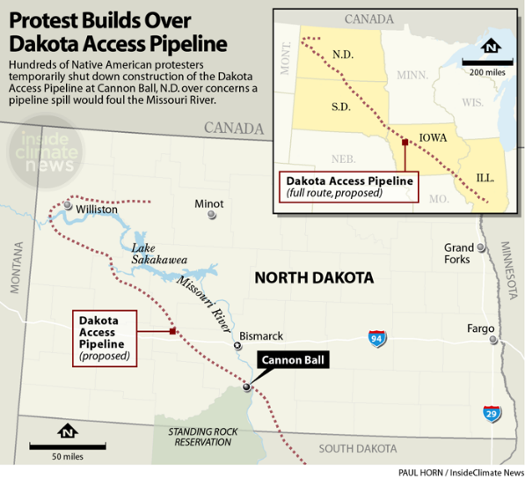
Protesters from dozens of tribes across the country are now camping in tents, tepees and mobile homes at the Sacred Stone Camp a mile and a half from the construction site.
"We have to be here," David Archambault II, the chairman of the Standing Rock Sioux tribe, who was arrested at the site last week, said in a statement. "We have to stand and protect ourselves and those who cannot speak for themselves."
The pipeline's builder, Energy Transfer Partners, said through a spokesperson, "This is an important energy infrastructure project that benefits all Americans and our national economy," it said.

The Standing Rock tribe, one of the poorest communities in the nation according to 2010 census data cited by the tribe, relies on the Missouri River for drinking water, irrigation, fishing and recreation, and for cultural and religious practices. The reservation covers about 3,600 square miles along the river.
"An oil spill would represent a genuine catastrophe for the people who live there," said Jan Hasselman, an attorney with Earthjustice, an environmental organization that filed a lawsuit on behalf of the Standing Rock Tribe against the U.S. Army Corps of Engineers, which approved the pipeline. "It isn't just cultural and religious, it's their economic lifeblood."
Protests against the pipeline have been ongoing since April. In July, a group of roughly two dozen from the Standing Rock tribe completed a nearly 2,000-mile relay from Cannon Ball to Washington, D.C. They delivered a petition with 150,000 signatures to the Corps calling on it to halt construction of the project.
On July 25, the Corps approved construction of the section of the pipeline upstream from the Standing Rock reservation, and ground was broken on August 10. Protests at the site started small, with about 50 people and grew to an estimated 1,200 on Wednesday, according to Morton County Sheriff Kyle Kirchmeier.
While the protest in Cannon Ball is primarily Native Americans, ranchers are challenging the project elsewhere along its 1,168-mile path. On August 9, lawyers representing 14 Iowa landowners filed a motion to halt construction of the pipeline across their property. The suit challenged Dakota Access's use of eminent domain to seize land for what it says is private use.
Over the past year, protests against fossil fuel infrastructure projects nationwide have increased, and at least 24 dozen projects have been rejected or canceled for myriad reasons, the most prominent among them the Keystone XL pipeline.
Protesters at the Sacred Stone Camp said they are hopeful that a federal court will rule in their favor when their case is heard on August 24. In the meantime, they are planning to continue their protests.
Possible Response Questions:
- How is the Dakota Pipeline related the life of the Standing Rock Tribe?
- Can you elaborate on the reasons the Standing Rock Tribe AND the Iowa landowners are challenging the Dakota Pipeline project?
- How would you defend the position of Energy Transfer Partners, the pipeline’s builder, and the U.S. Army Corps of Engineers, the group that approved the pipeline?
- Pick a passage from the article and respond to it.

