Name: ___________________________
Date: ____________________________
Map of East Asia

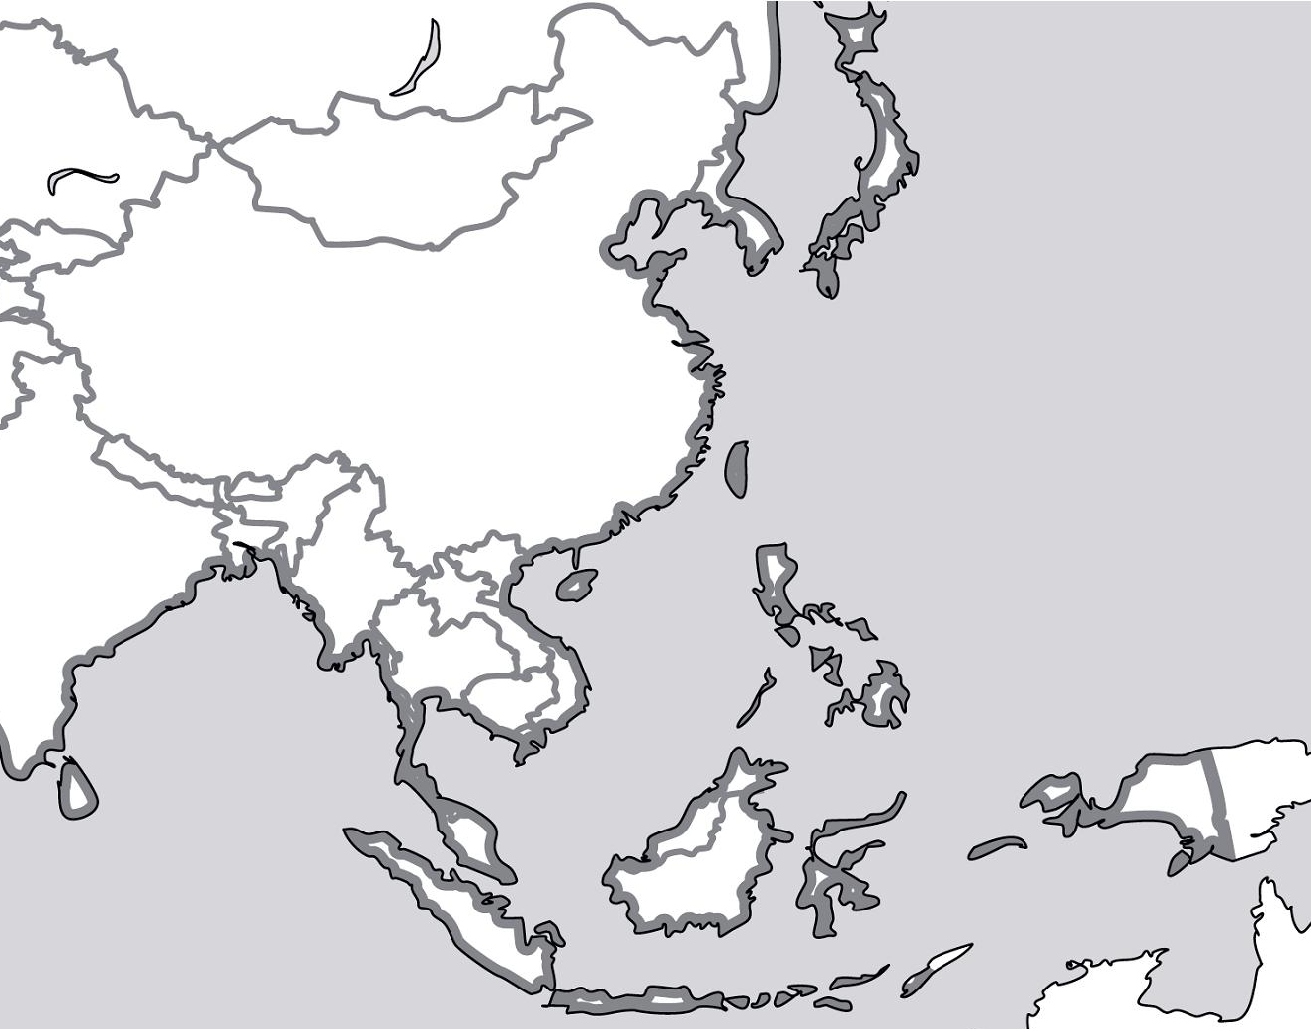

Map of East Asia

- The countries: China, Mongolia, North Korea, South Korea, Japan, The Philippines, Taiwan, Vietnam, Cambodia, Thailand, Myanmar, Laos, Malaysia, Indonesia, India, Russia
- The capitals of these countries
- Pacific Ocean
- South China Sea
- Andaman Sea
- Bay of Bengal
- Gulf of Thailand
- Philippine Sea
- East China Sea
- Yellow Sea
- Sea of Japan
- Yangtze River
- Huang River
- Xi River
- Gobi Desert
- Tarim Basin
- Kulun Mts.
- Mt. Fuji
- Altai Mts.

Use page A14-15 to label all the items above on your map.

