Name: _________________________ Date: __________________________ Period: ________
Map of Latin America
Label the following using pages A8-A9:
- All the countries and their capitals
- Pacific Ocean
- Atlantic Ocean
- Gulf of Mexico
- Gulf of California
- Caribbean Sea
- Lake Titticaca
- Lago de Nicaragua
- Amazon River
- Andes Mtns
- Pampas
- Patagonia
- Galapagos Islands
- Baja California
- Cape Horn

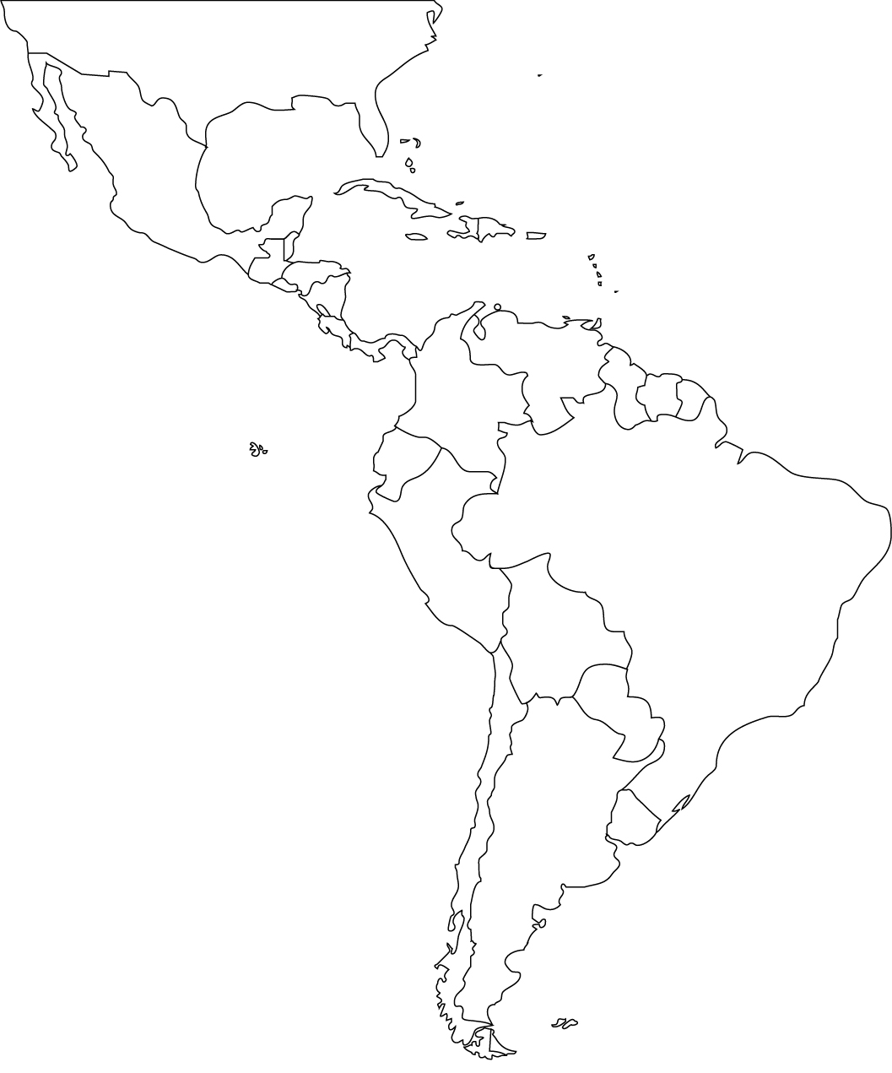

Countries:
- Belize
- Costa Rica
- El Salvador
- Guatemala
- Honduras
- Mexico
- Nicaragua
- Panama
- Argentina
- Bolivia
- Brazil
- Chile
- Colombia
- Ecuador
- Guyana
- Paraguay
- Peru
- Uruguay
- Venezuela
- Bahamas
- Cuba
- Dominican Republic
- Haiti
- Jamaica
- Puerto Rico

