Instructions to make a KWL Chart (American Revolution)

- Fold a piece of binder paper into thirds (see below).

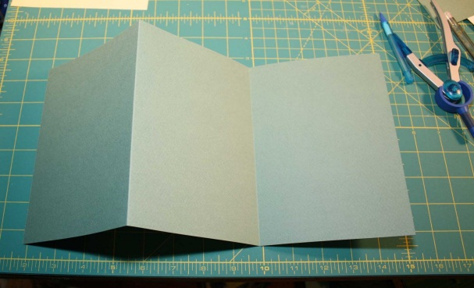

- In the first column write “What I know about the American Revolution”.
  - Write down six things you know about the American Revolution in this column. Bullet points are encouraged.

- In the second column write “What I want to know about the American Revolution”.
  - Write down six things you want to know about the American Revolution in this column. Bullet points are encouraged.

- In the third column write “What I learned about the American Revolution (from this movie)”.
  - Write down ten things you learned about the American Revolution from watching The Patriot in this column. Bullet points are still encouraged.
  - Fill in this section while you are watching the movie.

