Geography Spark
Copy the title and the following prompt to your notes and answer/respond in 3-5 sentences.

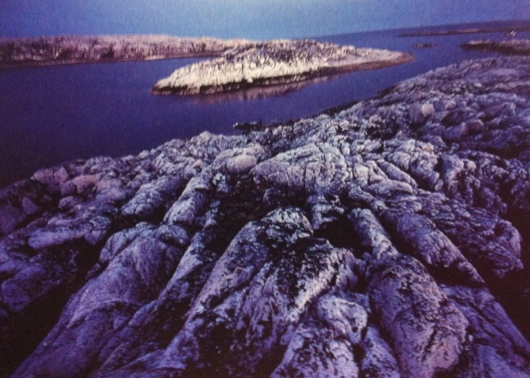
Sp30: “The Canadian Shield”
In Canada there is an area of exposed bedrock called the Canadian Shield. During the Ice Age, which ended about 10,000 years ago, glaciers scraped the ancient bedrock of overlying materials. Why do you think this region is so sparsely populated?

