Geography Spark
Copy the title and the following prompt to your notes and answer/respond in 3-5 sentences.

Sp1: “Migration” pg 4
Before we learn anything about migration in this class, what do you think about it? What are migrants? What do you think are some reasons that people migrate?

Geography Spark
Copy the title and the following prompt to your notes and answer/respond in 3-5 sentences.

Sp2: “Free Write” pg 4
Today you can choose your topic. Write about whatever you like, use five lines in your notebook to do this free write, and do not write this prompt. Keep it school appropriate, and remember that I am a mandatory reporter.

Geography Spark
Copy the title and the following prompt to your notes and answer/respond in 3-5 sentences.

Sp3: “Migration Challenges” pg 8
When someone migrates from their homeland to another country what types of things do they need to prepare for? Consider factors like learning a new language, new customs, finding jobs, etc. If you know someone that has migrated to a new country, imagine their struggles.

Geography Spark
Copy the title and the following prompt to your notes and answer/respond in 3-5 sentences.

Sp4: “Pretest” pg 8
Look back at your Diverse Issues Pretest (page 7). What was the most surprising thing you learned from this test? Why?

Geography Spark
Copy the title and the following prompt to your notes and answer/respond in 3-5 sentences.

Sp5: “Free Write” pg 10
Today you can choose your topic. Write about whatever you like, use five lines in your notebook to do this free write, and do not write this prompt. Keep it school appropriate, and remember that I am a mandatory reporter.

Geography Spark
Copy the title and the following prompt to your notes and answer/respond in 3-5 sentences.

Sp6: “What Countries are in Latin America?” pg 10
List as many countries as you can that you know are in Latin America (don’t look at your map). What do you know about Central and South America?

Geography Spark
Copy the title and the following prompt to your notes and answer/respond in 3-5 sentences.

Sp7: “Indigenous Rights” pg 12
“Most governments in Latin America have failed to recognize the rights of indigenous people and their right to their own traditional territories.” 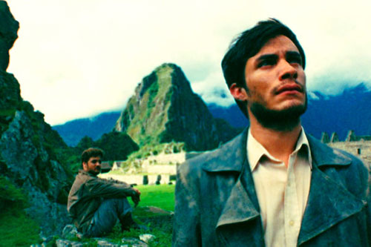
Watch the video clip from the movie The Motorcycle Diaries. Using the information from that clip, what do you think of this quote?

Geography Spark
Copy the title and the following prompt to your notes and answer/respond in 3-5 sentences.

Sp8: “Free Write” pg 12
Today you can choose your topic. Write about whatever you like, use five lines in your notebook to do this free write, and do not write this prompt. Keep it school appropriate, and remember that I am a mandatory reporter.

Geography Spark
Copy the title and the following prompt to your notes and answer/respond in 3-5 sentences.

Sp9: “Problems in Latin America’s history” pg 14
What problems have occurred in the history of Latin America? Consider the conquistadors, caudillos, and relying on a cash crop economy. Use the notes we have taken so far.

Geography Spark
Copy the title and the following prompt to your notes and answer/respond in 3-5 sentences.

Sp10: “Land in Latin America” pg 14
How would you describe the physical landscape of Latin America? In other words, what does the land look like? Consider mountain ranges, rivers, oceans, etc.

Geography Spark
Copy the title and the following prompt to your notes and answer/respond in 3-5 sentences.

Sp11: “Free Write” pg 20
Today you can choose your topic. Write about whatever you like, use five lines in your notebook to do this free write, and do not write this prompt. Keep it school appropriate, and remember that I am a mandatory reporter.

Geography Spark
Copy the title and the following prompt to your notes and answer/respond in 3-5 sentences.

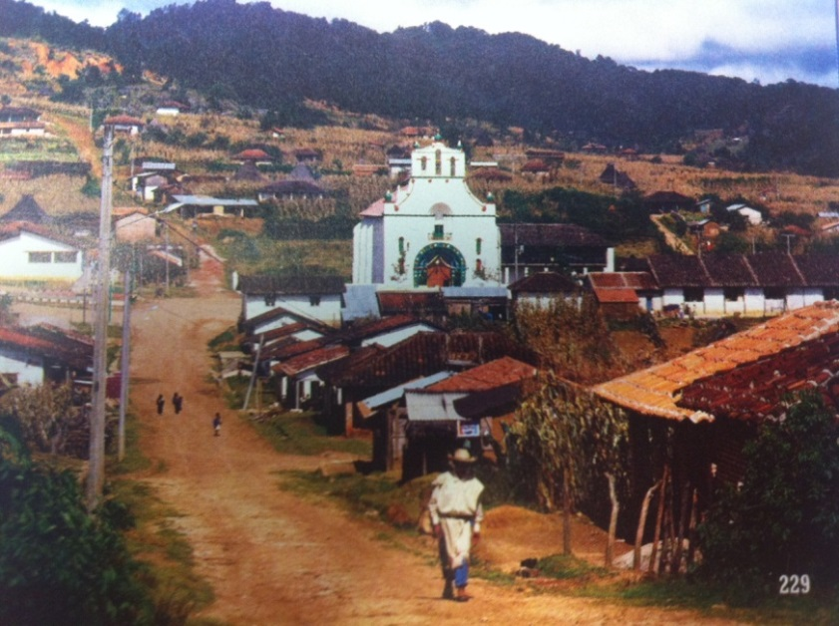
Sp12: “Subsistence Farming” pg 20
Many famers in Mexico practice subsistence farming. This means they grow only enough crops to meet their family’s needs. How does this picture indicate that villagers grow their own food? What do you think are the benefits and challenges of subsistence farming?

Geography Spark
Copy the title and the prompt into your notes. Then respond in 3-5 sentences.

Sp13: “Amazon River” pg 24
The Truckee River runs through Reno and has a major impact on our community. What ways does the river affect you? How do you think the Amazon River might affect the country of Brazil, especially those living nearby?

Geography Spark
Copy the title and the prompt into your notes. Then respond in 3-5 sentences.

Sp14: “Cash Crops” pg 26
The Andes offer soil and climate perfect for growing coffee. Colombia is a world leader in coffee production, and coffee makes up half of all Colombian agricultural exports. What is the danger of a country’s dependence on a single cash crop for income?

Geography Spark
Copy the title and the prompt into your notes. Then respond in 3-5 sentences.
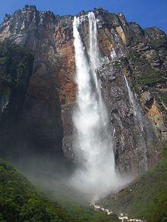
Sp15: “Angel Falls” pg 26
Angel Falls, Venezuela, is about 20 times as high as Niagara Falls. This waterfall explodes out of caves in the cliff and plunges down to the Churún River. Why do you think the Venezuelan government created a national park around the falls?

Geography Spark
Copy the title and the following prompt to your notes and answer/respond in 3-5 sentences.

Sp16: “Transculturation” pg 28
Watch the following video about revolutions in Latin America, paying particular attention to the concept of transculturation, and to Símon Bolivar’s attempt to unify Venezuelans based on the idea of their South American-ness. How do you think cultural identify forces people to be unified? To be fragmented?

http://www.youtube.com/watch?v=ZBw35Ze3bg8

Geography Spark
Copy the title and the following prompt to your notes and answer/respond in 3-5 sentences.

Sp17: “Free Write” pg 28
Today you can choose your topic. Write about whatever you like, use five lines in your notebook to do this free write, and do not write this prompt. Keep it school appropriate, and remember that I am a mandatory reporter.

Geography Spark
Copy the title and the following prompt to your notes and answer/respond in 3-5 sentences.

Sp18: “Migration Review” pg 30
Let’s review. What is migration? What is the difference between immigration and emigration?

Geography Spark
Copy the title and the following prompt to your notes and answer/respond in 3-5 sentences.

Sp19: “Climate vs. Weather” pg 30
What is the difference between climate and weather?
**I didn’t print this out because it is one sentence. You guys can copy the prompt into your journals.

Geography Spark
Copy the title and the following prompt to your notes and answer/respond in 3-5 sentences.

Sp20: “Appealing Climates” pg 32
Of the climates we have learned about so far, which one do you think sounds most appealing? In other words, if you had to live in one climate for the rest of your life which would you pick? Why?
SciShow: A History of the Earth’s Climate
http://www.youtube.com/watch?v=dC_2WXyORGA

Geography Spark
Copy the following title and prompt into your journal. Answer the prompt in three to five sentences.

Sp21: “Tectonic Plates” pg 32
How do you think volcanoes are formed? Mountains?

**I didn’t print this out because it is one sentence. You guys can copy the prompt into your journals.
Bill Nye- Plate Tectonics
http://www.youtube.com/watch?v=lJiAUvB1vEU

Geography Spark
Copy the following title and prompt into your journal. Answer the prompt in three to five sentences.

Sp22: “Pangaea” pg 34
What is Pangaea? Explain what Pangaea has to do with the tectonic plates we have been learning about over the last few days.

Geography Spark
Copy the following title and prompt into your journal. Answer the prompt in three to five sentences.

Sp23: “Layers of the Earth” pg 34
Describe the layers of the earth from the inside out in as much detail as you can. Use your previous knowledge or Google if you need to.

Geography Spark
Copy the title and the following prompt to your notes and answer/respond in 3-5 sentences.

Sp24: “Communism” pg 38
The words “communist” and “communism” get thrown around a lot, especially when people talk about China. Do you really know what it means? In your own words, explain what you think communism is.

Geography Spark

Sp25: “Free Write” pg38
Today you can choose your topic. Write about whatever you like, use five lines in your notebook to do this free write, and do not write this prompt. Keep it school appropriate, and remember that I am a mandatory reporter.

Geography Spark
Glue the prompt onto the appropriate page of your interactive notebook. Then respond to the prompt in 3-5 sentences. You get 2 points per thoughtful sentence (cap at 6 points).

Sp26: “Chinese Culture” pg 40
What aspects of Chinese culture have been incorporated into American life? How do you think that this happened?

Geography Spark
Glue the prompt onto the appropriate page of your interactive notebook. Then respond to the prompt in 3-5 sentences. You get 2 points per thoughtful sentence (cap at 6 points).

Sp27: “After the Second Sino-Japanese War” pg40
Recap, in your own words, how the Communist party was able to take over China.
**I did not print this prompt because it is only one sentence. Please write it in your notebook.

Geography Spark
Glue the prompt onto the appropriate page of your interactive notebook. Then respond to the prompt in 3-5 sentences. You get 2 points per thoughtful sentence (cap at 6 points).

Sp28: “The People’s Communes” pg 42
Mao Zedong tried to introduce People’s Communes in China in order to try to increase production. These were self-sufficient communal settlements that had both farms and industry. However instead of production growing, it decreased. Explain why this happened and list ideas Mao could have used to fix the problem.

Geography Spark

Sp29: “Free Write” pg 46
Today you can choose your topic. Write about whatever you like, use five lines in your notebook to do this free write, and do not write this prompt. Keep it school appropriate, and remember that I am a mandatory reporter.

Geography Spark
Glue the prompt onto the appropriate page of your interactive notebook. Then respond to the prompt in 3-5 sentences. You get 2 points per thoughtful sentence (cap at 6 points).

Sp30: “Tiananmen Square” pg 46
What is martial law? What happened at the Tiananmen Square protest in China in 1989? Do you think it is acceptable to declare martial law in a situation like this? Why?

Geography Spark
Glue the prompt onto the appropriate page of your interactive notebook. Then respond to the prompt in 3-5 sentences. You get 2 points per thoughtful sentence (cap at 6 points).

Sp31: “What makes a country?” pg 48
What do all countries have in common? What do you think are the qualities that can make a place a country? Explain.

Geography Spark
Glue the prompt onto the appropriate page of your interactive notebook. Then respond to the prompt in 3-5 sentences. You get 2 points per thoughtful sentence (cap at 6 points).

Sp32: “Sovereignty” pg 48
What is sovereignty? Why do you think it is such a big deal for a country to be considered sovereign? How do you think a country could lose its sovereignty?

Geography Spark
Glue the prompt onto the appropriate page of your interactive notebook. Then respond to the prompt in 3-5 sentences. You get 2 points per thoughtful sentence (cap at 6 points).

Sp33: “Types of Government” pg 54
Review the outline called “Political and Economic Systems” that we were working on before break. List at least three different types of government that we took notes on, and explain one below.

Geography Spark

Sp34: “Free Write” pg 56
Today you can choose your topic. Write about whatever you like, use five lines in your notebook to do this free write, and do not write this prompt. Keep it school appropriate, and remember that I am a mandatory reporter.

Geography Spark
Glue the prompt onto the appropriate page of your interactive notebook. Then respond to the prompt in 3-5 sentences. You get 2 points per thoughtful sentence (cap at 6 points).

Sp35: “Types of Economies” pg 56
Define the following
- Traditional economy
- Market economy
- Command economy
Which type sounds the best to you?

Geography Spark

Sp36: “Free Write” pg 62
Today you can choose your topic. Write about whatever you like, use five lines in your notebook to do this free write, and do not write this prompt. Keep it school appropriate, and remember that I am a mandatory reporter.

Geography Spark
Glue the prompt onto the appropriate page of your interactive notebook. Then respond to the prompt in 3-5 sentences. You get 2 points per thoughtful sentence (cap at 6 points).

Sp37: “Russian Vacation” pg 62
What clothes do you think you would need to pack on a vacation to Russia? Consider traveling in the north of the country, and the south of the country. What about in the summer vs. the winter?

Geography Spark
Glue the prompt onto the appropriate page of your interactive notebook. Then respond to the prompt in 3-5 sentences. You get 2 points per thoughtful sentence (cap at 6 points).

Sp38: “Review of Communism” pg 64
Look back at your notes on China. What is communism again? How does communism relate to Russia? Then look at your outline called “Political and Economic Systems”. What is a command economy?

Geography Spark
Glue the prompt onto the appropriate page of your interactive notebook. Then respond to the prompt in 3-5 sentences. You get 2 points per thoughtful sentence (cap at 6 points).

Sp39: “Headlines” pg 64
Lately the countries of Russia and Ukraine have been in the news a lot. List some of the headlines or news you have heard about these countries. What is going on with them right now?

Geography Spark
Glue the prompt onto the appropriate page of your interactive notebook. Then respond to the prompt in 3-5 sentences. You get 2 points per thoughtful sentence (cap at 6 points).

Sp40: “Crimea” pg 68
Where is the Crimean Peninsula located? Why did the Crimean Crisis start? How did Russia get involved?

Geography Spark

Sp41: “Free Write” pg 68
Today you can choose your topic. Write about whatever you like, use five lines in your notebook to do this free write, and do not write this prompt. Keep it school appropriate, and remember that I am a mandatory reporter.

Geography Spark
Glue the prompt onto the appropriate page of your interactive notebook. Then respond to the prompt in 3-5 sentences. You get 2 points per thoughtful sentence (cap at 6 points).

Sp42: “President Obama” pg 70
What is a sanction? Why did Obama threaten to put sanctions on Russia? Why might the U.S. and other countries be unhappy if Russia gets to keep control of the Crimean Peninsula?

Geography Spark
Glue the prompt onto the appropriate page of your interactive notebook. Then respond to the prompt in 3-5 sentences. You get 2 points per thoughtful sentence (cap at 6 points).

Sp43: “Review” pg 70
Look way back to your notes on climate. Pick and describe two climate types that you would like to live in. Then pick one climate you would not want to live in, and describe that.

Geography Spark

Sp44: “Free Write” pg 72
Today you can choose your topic. Write about whatever you like, use five lines in your notebook to do this free write, and do not write this prompt. Keep it school appropriate, and remember that I am a mandatory reporter.

Geography Spark
Glue the prompt onto the appropriate page of your interactive notebook. Then respond to the prompt in 3-5 sentences. You get 2 points per thoughtful sentence (cap at 6 points).

Sp45: “Digestion” pg 72
“If you cannot prevent your enemies from swallowing you, at least prevent them from digesting you.” – Jean-Jacques Rousseau
What do you think this quote means? How could this apply to a country such as Poland?

Geography Spark
Glue the prompt onto the appropriate page of your interactive notebook. Then respond to the prompt in 3-5 sentences. You get 2 points per thoughtful sentence (cap at 6 points).

Sp46: “Holocaust in Poland” pg 74
What is the Holocaust? What happened to Jewish people living in Poland during this time? What is a ghetto?

Geography Spark
Glue the prompt onto the appropriate page of your interactive notebook. Then respond to the prompt in 3-5 sentences. You get 2 points per thoughtful sentence (cap at 6 points).

Sp47: “Velvet Revolution” pg 74
During the 1980’s and 1990’s Czechoslovakia experience what is called a “velvet revolution” which is a revolution that results in major political changes without any bloodshed. Why do you believe that velvet revolutions are a rare occurrence in the world?

Geography Spark
Glue the prompt onto the appropriate page of your interactive notebook. Then respond to the prompt in 3-5 sentences. You get 2 points per thoughtful sentence (cap at 6 points).

Sp48: “Independence from the Soviet Union” pg 77
In the 1990’s, during the breakup of the Soviet Union, many countries left the U.S.S.R. and once again became independent, sovereign nations. These countries included: Armenia, Azerbaijan, Belarus, Estonia, Georgia, Kazakhstan, Kyrgyzstan, Latvia, Lithuania, Moldova, Tajikistan, Turkmenistan, Ukraine, and Uzbekistan. What do you think are the benefits of being an independent country? What are the challenges?
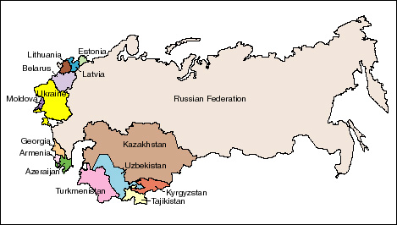

Geography Spark

Sp49: “Free Write” pg 77
Today you can choose your topic. Write about whatever you like, use five lines in your notebook to do this free write, and do not write this prompt. Keep it school appropriate, and remember that I am a mandatory reporter.

Geography Spark
Glue the prompt onto the appropriate page of your interactive notebook. Then respond to the prompt in 3-5 sentences. You get 2 points per thoughtful sentence (cap at 6 points).

Sp50: “Totalitarianism” pg 79
One extreme form of a dictatorship is totalitarianism. This occurs when the government tries to control every part of society – politics, economy, and people’s personal lives. What are the pros and cons of this type of government?

