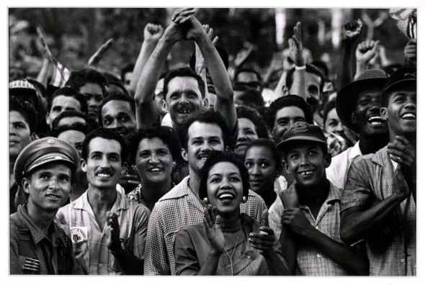
Burt Glinn, Thousands of supporters flocked in front of the Presidential Palace in Havana to welcome their liberator Fidel Castro and the newly appointed Dr. Manuel Urruti, Havana, Cuba, January 9, 1959

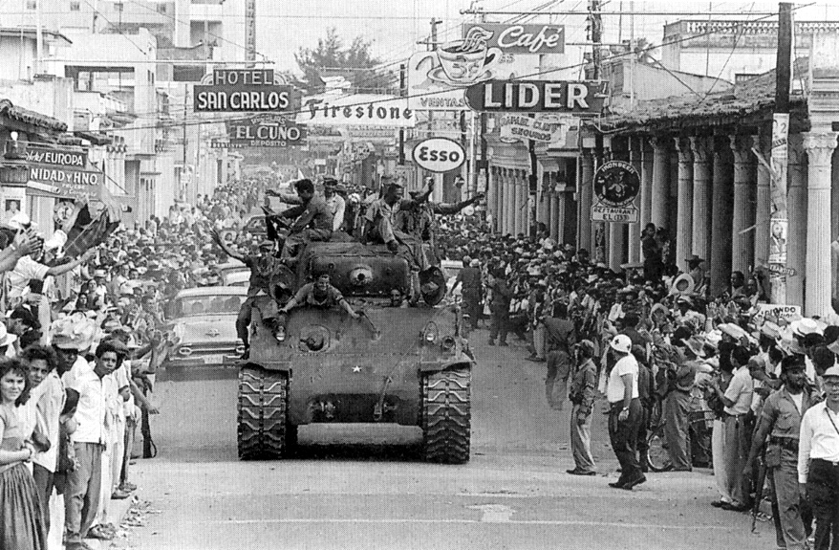
Cuban Revolution 1959 . Communist forces led by Fidel Castro Enter Havana.
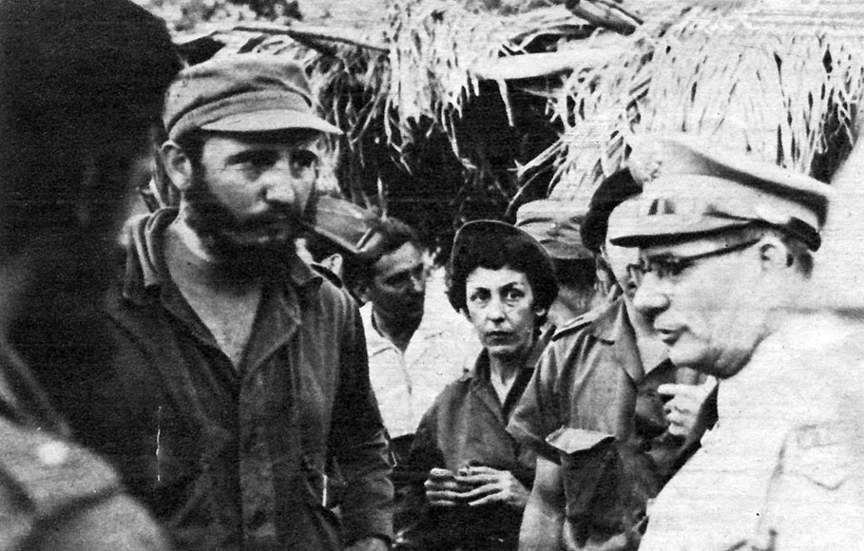
Fidel Castro, Celia Sanchez, and Col. Jose M. Rego Rubido, who negotiated the surrender of Santiago de Cuba to rebel forces.

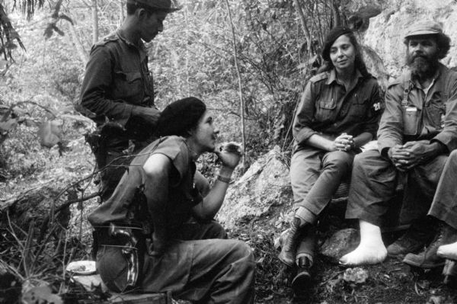
Raúl Castro, Vilma Espin and Others by Cliff, Cuban Revolution

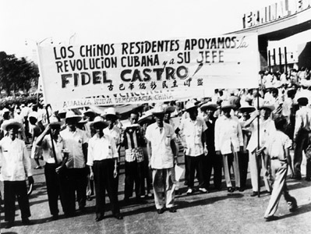
Cubans of Chinese descent participating in a demonstration around the time of the Cuban Revolution. Cuba brought over one hundred thousand indentured servants from China to work in its vast sugarcane fields during the nineteenth century.
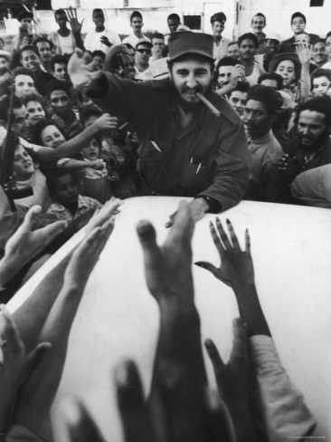
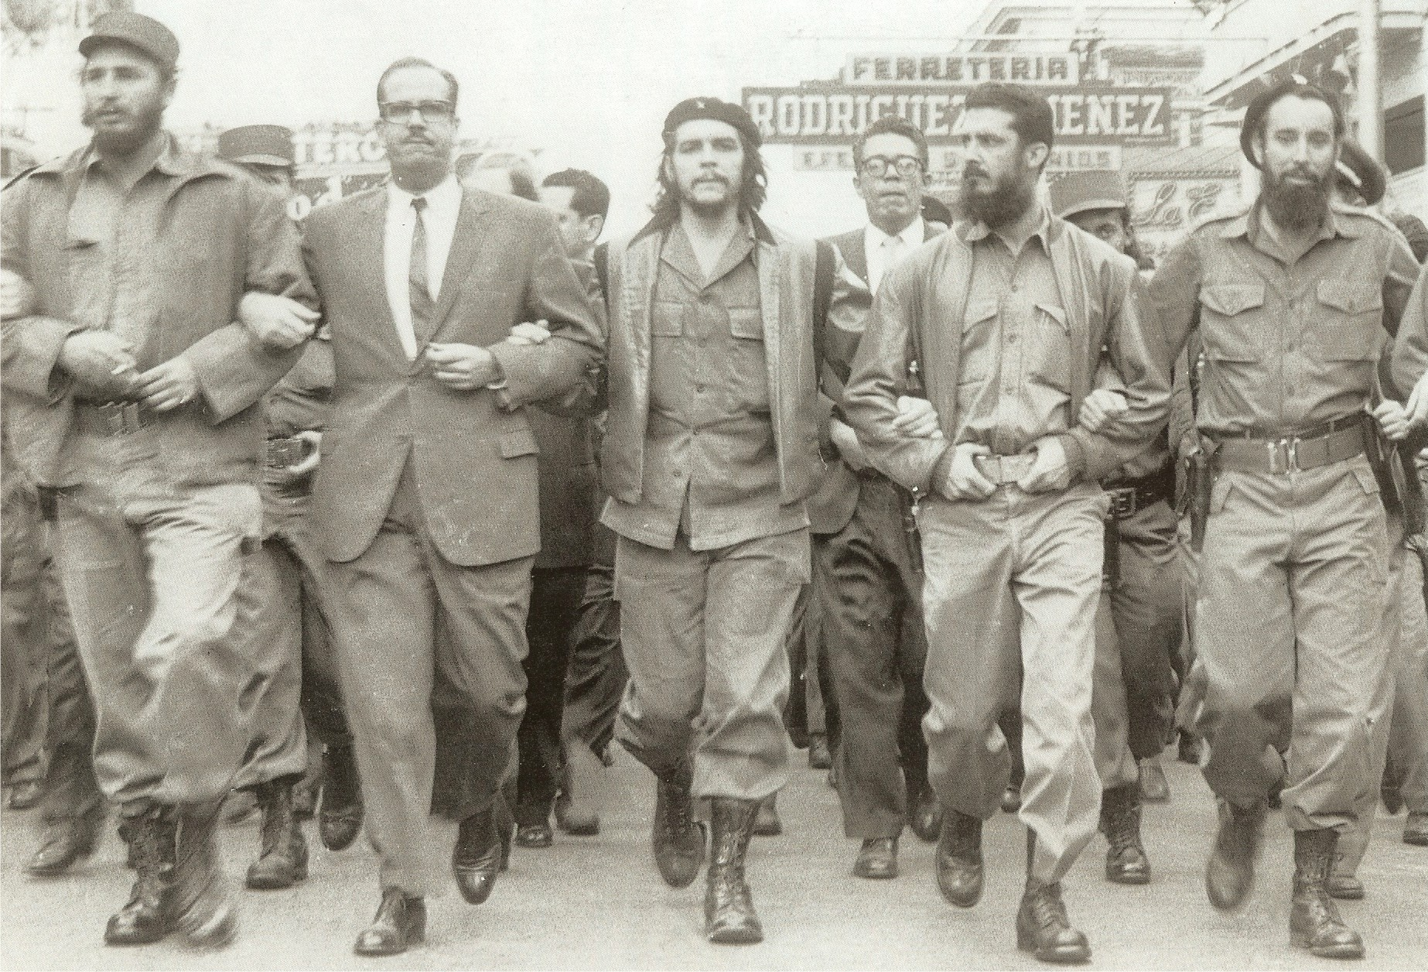
On January 1st 1959, U.S. backed dictator of Cuba, Fulgencio Batista fled the island for the Dominican Republic following the Battle of Santa Clara. This ushered in the communist government, led by Fidel Castro, that remains in power today.



