Name: _________________________________
Date: __________________________________
Period: _____
Civil War Photography as a Primary Source

What is a primary source?

Picture #1

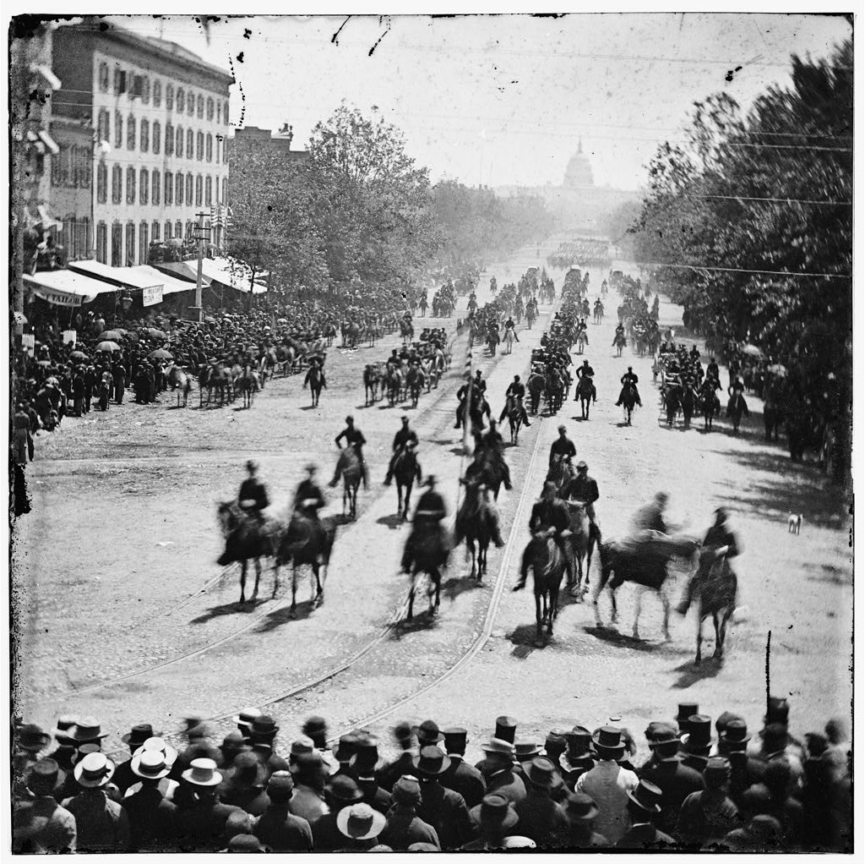
1. What do you notice first about this picture? What stands out?

2. Where do you think this photograph was taken? How can you tell?

3. Do you think this was early in the war or closer to the end? Why do you think that?

4. Why do you think men on horses are going down the street?

5. Why do you think people are out on the street watching this?

6. Do you think this is a sad or happy occasion? Explain your answer.

7. List one or two things that this picture tells you about the war.

Picture #2
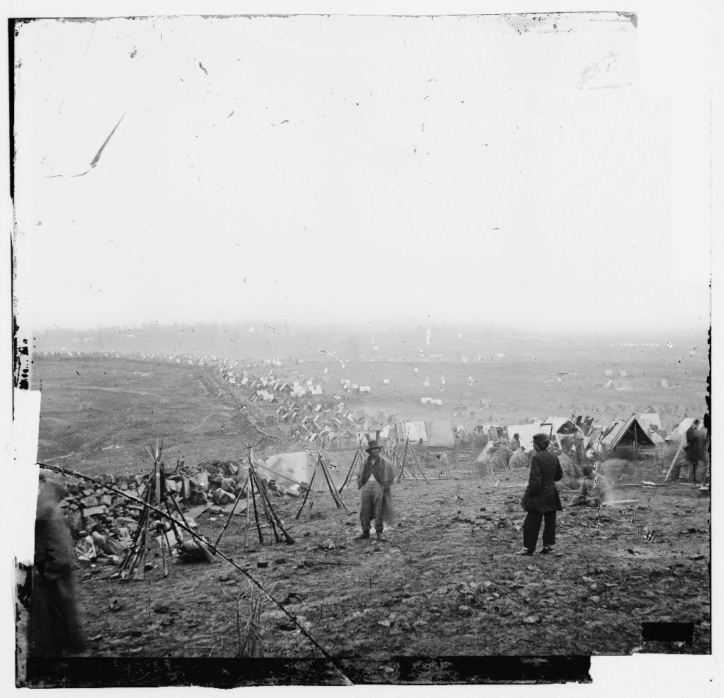

8. What do you notice first about this picture? What stands out?

9. What time of the year do you think it is? How can you tell?

10. Where do you think this photograph was taken?

11. Which army do you think this is? The Union of the Confederate, explain your answer.

12. Look closely, what are some tasks the men are doing in this picture?

13. Do you think this looks like a good or bad place to live? Why?

14. List one or two things that this picture tells you about the war.
Picture #3
15. What do you notice first about this picture? What stands out?

16. What time of the year do you think is it? How can you tell?

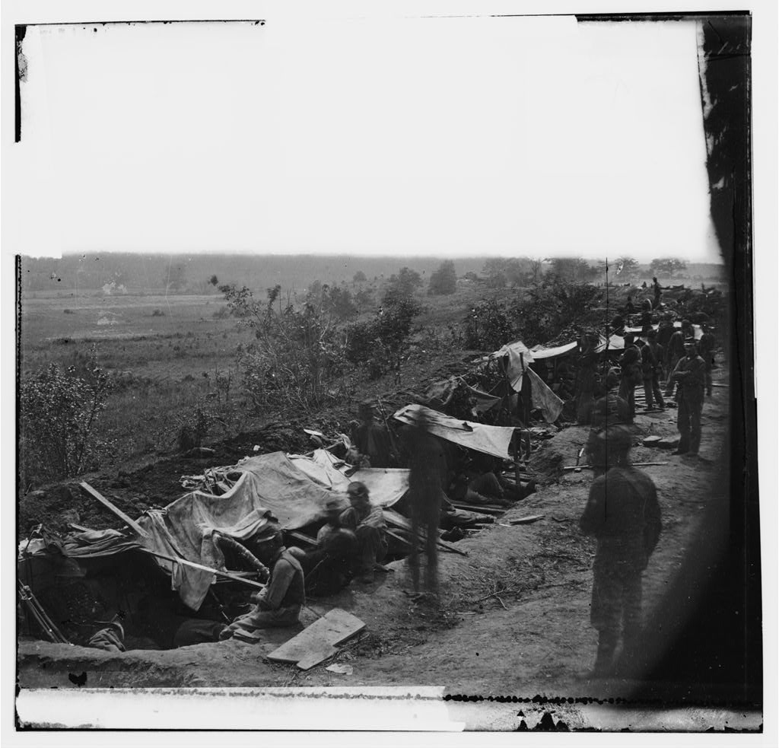
17. Do you think these men are from the Union or from the Confederacy? How can you tell?

18. What have the men done to the ground?

19. Do you think this is a place where the soldiers will live like a camp, or do you think this is set up for some other reason? Explain your answer.

20. List one or two things that this picture tells you about the war.

Picture #4
21. What do you notice first about this picture? What stands out?

22. Do you think these soldiers are Union or Confederate? What clues help you answer that question?

23. Where do you think is photograph was taken?

24. What time of the year is it? How can you tell?

25. Look closely at the men in the picture. Do you think the soldiers are important? Why or why not?

26. What do you think was happening the day this picture was taken? Explain your thoughts.

27. List one or two things that this picture tells you about the war.

