2017 National History Day Packet

Taking a Stand in History
NHD 2017

Name: ________________________________

Social Studies Class Period: _____
(Kristen Quintana’s Class)

English Class Period: _____
(Kristin Moffitt’s Class)

Project Due Date: ________________________

Project Showcase Night: __________________

Table of Contents
- Cover page
- Table of Contents
- What is National History Day?
- Schedule of Due Dates
- 2017 Theme Narrative: Taking a Stand in History
- 2017 Theme Narrative: Taking a Stand in History (cont.)
- 2017 Theme Narrative: Taking a Stand in History (cont.)
- US History Sample Topics
- European History Sample Topics
- World History Sample Topics
- Taking a Stand in History: What does it mean to take a stand?
- Topic Brainstorm
- Narrowing My Topic
- Choosing My Topic
- Resources and Information Document
- Analyzing My Topic
- How Do I Choose My Project?
- Connecting My Topic to Taking a Stand in History
- Finding Information about your Topic
- Finding Information about your Topic (answer questions)
- Research Questions
- Thesis = Topic + Theme + Impact
- Thesis = Topic + Theme + Impact (cont.)
- Worksheet: Historical Context
- Historical Context Paragraph
- Historical Significance
- Historical Significance (cont.) + Revising Your Thesis
- Historical Significance Paragraph
- Topic Organizer
- Making a “Map” for Your Project + Revising Your Thesis AGAIN!
- Source 1
- Source 2
- Source 3
- Source 4
- Source 5
- Parenthetical Documentation
- Example of a Final Annotated Bibliography
- NHD Project Grading Rubric

What is National History Day?

National History Day® (NHD) is a nonprofit organization that creates opportunities for teachers and students to engage in historical research. NHD is not a predetermined, by-the-book program but rather an innovative curriculum framework in which students learn history by selecting topics of interest and launching into a year-long research project. The mission of NHD is to improve the teaching and learning of history in middle and high school. The most visible vehicle is the NHD Contest.

When studying history through historical research, students and teachers practice critical inquiry, asking questions of significance, time, and place. History students become immersed in a detective story. Beginning in the fall, students choose a topic related to the annual theme and conduct extensive primary and secondary research. After analyzing and interpreting their sources and drawing conclusions about their topics’ significance in history, students present their work in original papers, exhibits, performances, websites, or documentaries. These projects are entered into competitions in the spring at local, affiliate, and national levels, where they are evaluated by professional historians and educators. The program culminates at the national competition held each June at the University of Maryland at College Park.

Each year National History Day uses a theme to provide a lens through which students can examine history. The theme for 2017 is Taking a Stand in History. The annual theme frames the research for both students and teachers. It is intentionally broad enough that students can select topics from any place (local, national, or world) and any time period in history. Once students choose their topics, they investigate historical context, historical significance, and the topic’s relationship to the theme by conducting research in libraries, archives, and museums, through oral history interviews, and by visiting historic sites.

NHD benefits both teachers and students. For the student, NHD allows control of his or her own learning. Students select topics that match their interests. Program expectations and guidelines are explicitly provided for students, but the research journey is driven by the process and is unique to the historical research. Throughout the year, students develop essential life skills by fostering intellectual curiosity and academic achievement. In addition, students develop critical-thinking and problem-solving skills that will help them manage and use information now and in the future.

The student’s greatest ally in the research process is the classroom teacher. NHD supports teachers by providing instructional materials and through workshops at local, affiliate, and national levels. Many teachers find that incorporating the NHD theme into their regular classroom curriculum encourages students to watch for examples of the theme and to identify connections in their study of history across time.

NHD’s work with teachers and students extends beyond the contest and includes institutes and training programs, which provide teachers with opportunities to study history and develop lessons and materials they can share with their students. In addition, NHD offers continuing education courses for teachers (for graduate credit or professional development hours) to improve classroom practice. NHD also offers teaching resources to help teachers integrate primary sources and critical thinking into the classroom. These resources are free and accessible to all teachers. Visit www.nhd.org to learn more.

Schedule of Due Dates

Topic narrowed, selected, and presented
to Kristin & Kristen ________________________________

Type of project selected and presented
to Kristin & Kristen ________________________________

Research questions written ________________________________

Thesis Statement written ________________________________

Sources – Check 1
Must have at least two sources ________________________________

Historical Context paragraph written ________________________________

Historical Significance paragraph written ________________________________

Sources – Check 2
Must have at least five sources ________________________________

Annotated bibliography completed ________________________________

Peer editing completed ________________________________

Project Due Date ________________________________

NHD Showcase Night (mandatory) ________________________________

Taking a Stand in History
What does it mean to take a stand? Understanding the NHD Theme

In the box below, explain in your own words what you think it means to “take a stand”.

Now read the next 3 pages in this packet, “2017 Theme Narrative: Taking a Stand in History”.

According to the second paragraph, What does it mean to “take a stand”?
List some examples of people or groups taking a stand:

What other information from this reading is important to understand what it means to “take a stand”?
Topic Brainstorm
A good way to choose a topic is to start with a general area of history you find interesting. This might be something you read about in a class or something related to family history. Using the chart below brainstorm one topic in each category that fits this year’s theme, Taking a Stand in History.

Politics |  | The Environment
Topic Idea |  | Topic Idea
Civil Rights |  | Social Issues
Topic Idea |  | Topic Idea
Military History |  | Religion
Topic Idea |  | Topic Idea
Science & Technology |  | Education
Topic Idea |  | Topic Idea
Business |  | Arts, Music, & Culture
Topic Idea |  | Topic Idea

Narrowing My Topic
Using the funnels below, try narrowing down two of your general interests into more focused topics.

Taking a Stand in History
Taking a Stand in History

Narrowed topic 1: ___________________________________________________

__________________________________________________________________

Narrowed topic 2: ___________________________________________________

__________________________________________________________________

Choosing My Topic

Narrowing a broad theme to a specific topic that you will enjoy will take some thought and investigation. Once you decide on a topic you must research it thoroughly.

Choosing a Topic
1. What is the theme?

2. What are my personal interests?

3. Look back at the worksheet with the funnels. What will my preliminary topic be?

4. How does my preliminary topic relate to this year’s theme?

Looking for Sources
5. Define primary source.

6. What primary sources are available on my topic?

7. Define secondary source.

8. What secondary sources are available on my topic?

Resources and Information Document
This document will likely be lengthy. Some people have up to 50 pages of copied resources in their list. The purpose of this Resources and Information Document is to help you find and remember information, record the source and keep you from plagiarizing.

In your Google Drive, create a document (titled “NHD 2017 Resources and Information Document” that lists first your website (URL) and the information that you copied from that website.

If you use other resources (like books or newsprint) be sure to copy down all important information so you can find it again once your paper is written (you will need to cite your information at the end of your paper in proper MLA formatting).

Here is a small segment as an example of what your document may look like:

http://www.psychologytoday.com/blog/pride-and-joy/201309/should-parents-praise-their-children
Kohn also argues that praise undermines a child’s intrinsic motivations and his confidence in his independent judgments. Our praise, Kohn believes, calls attention to our judgments, rather than a child’s inherent interest and pleasure in what he has accomplished. He warns that frequent praise may therefore create in children an “addiction” to praise—a hunger for external approval and a long-term sense of insecurity and inner pressure. Children become, in this way, “praise junkies.”
A Different Perspective on Praise
I would like to offer a different understanding of praise. In my view, a child’s need for praise and approval from admired adults is not an “extrinsic” reward. Tokens and money are extrinsic rewards. Praise, like a smile or a gleam in our eye, is different. It is a deeply intrinsic human need. If we think of praise in this way—as a basic need, not a “technique” for raising obedient children—our understanding (and our advice to parents) fundamentally changes.
Praise is ubiquitous in our adult lives. No matter how self-reliant we have become, the opinions of others (especially the opinions of people we look up to and admire) matter—to all of us, throughout life. When we have worked hard and done a good job, we want (and need) people to tell us that we’ve done a good job.
This summer, I spent a week at a music camp in Canada for amateur musicians of all ages, and praise was all around. Musicians, young and old, were told, “Good job!” (or, as the Canadians like to say, “Super!”) when they worked hard and played well. This praise was certainly not a form of control. It was encouragement – and its effect was encouraging.
Why should children be different? Don’t children deserve the same recognition and encouragement that we do, as adults?
*Then you will continue with the next resource that you find, put the resource link on your document and copy the information that you might use in your paper.

Analyzing My Topic

As you answer these questions about your topic you are analyzing and interpreting your resources and putting your topic into historical context and perspective.

Please Note: The questions on this page should be answered for topics about individuals or locations as well as for events.

1. What do I want to know about my topic?

2. What is the most interesting part of my topic?

3. When did the event occur? When did this person live?

4. What was happening? Where?

5. Why did it happen at this particular time and this particular place?

6. What preceded and, perhaps, caused this event?

7. What things were happening at the same time as this event?

8. What were the consequences of the event and how did they affect the future?

9. Why was this historical event significant?

How Do I Choose My Project?
Do you have special interests or talents that lend themselves to a specific category? How can your material best be expressed? Answering the following questions may help you decide.

Historical Paper
1. Do I enjoy writing?
2. Am I more comfortable expressing myself on paper rather than in front of an audience?
3. Am I trying to convey a complex idea that requires a lot of explanation?

Performance
1. Do I enjoy being in front of an audience?
2. Do I like to act?
3. Can I sing or play a musical instrument? (Musical talent is not necessary, but many students incorporate music into their performances.)
4. Can my topic be expressed dramatically?
*If you are interested in doing a performance it may be helpful to sign up for Pan’s Drama class

Exhibit
1. Do I enjoy creating things with my hands?
2. Do I have room to keep an exhibit once I create it?
3. Do I have a way to transport my project to a contest?
4. Can I tell my story primarily through pictures and artifacts instead of words?

Documentary
1. Do I have access to and enjoy working with media equipment?
2. Do I have access to editing equipment that I can operate?
3. Do I have a VCR, television, slide projector, tape recorder, computer, etc. that I can take to a contest?
4. Will my research be most clearly presented as a documentary?
*If you are interested in making a documentary it might be a good idea for you to sign up for Kristin’s Friday ID class

Websites
1. Do I enjoy working with computers?
2. Do I have access to a laptop computer to present my entry at the contest?
3. Do I have a basic knowledge about developing websites?
4. Can I effectively present my topic in a website?

Connecting My Topic to Taking a Stand in History
An important part of your National History Day project is connecting your topic to this year’s theme, Taking a Stand in History.

In the box below review what it means to “take a stand”.
How does your topic connect to this year’s theme, Taking a Stand in History? Try to think of both weak and strong connections to the theme and create bullet pointed lists.
Weak Connections
Strong Connections

In the box below write a paragraph (5+ sentences) that explains how your topic makes a meaningful connection

Finding Information about your Topic
There is so much information on the internet, and about your chosen topic. Where do you even begin your research? Writing research questions can give you a place to begin.
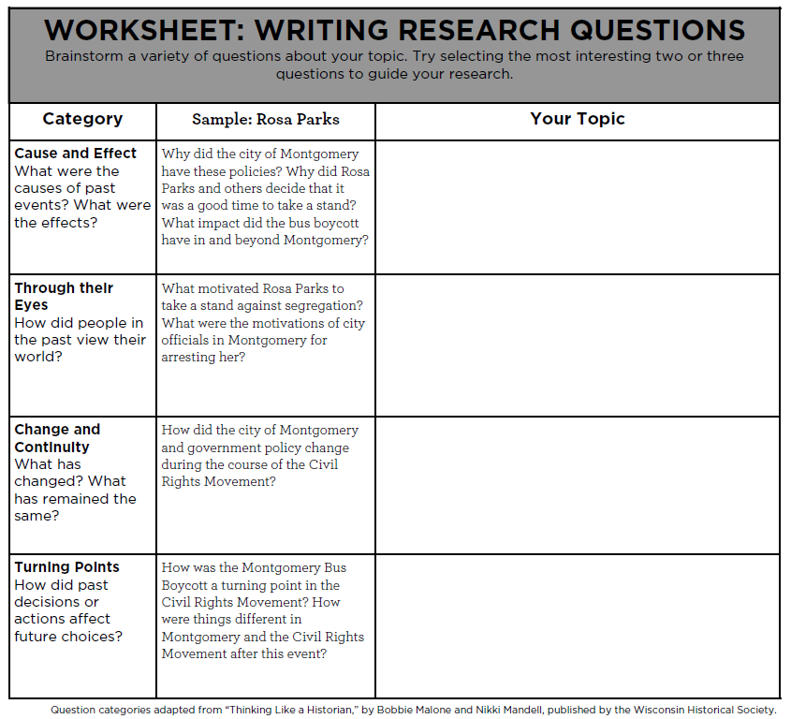

Finding Information about your Topic
There is so much information on the internet, and about your chosen topic. Where do you even begin your research? Writing research questions can give you a place to begin.

Pick the three most interesting questions from the previous page. Rewrite them in the boxes below, then answer them.

Question 3
Question 2
Question 1
Answer:
Answer:
Answer:

Research Questions

Topic: _________________________________________________________________

Who: Who was involved? Who was affected?

What: What happened? What was the main event?

Where: Where was/were the place(s) it took place?

When: When did it happen? How long of a time period was it?

Why: Why did it happen? What caused it?

Why: Why is it important? What were the outcomes?

Additional Questions:

Theme Connection: Taking a Stand in History

What meaningful connections have you found between your topic and this year’s theme?

Thesis = Topic + Theme + Impact
A thesis statement is a central thought that holds your entire National History Day (NHD) project together. Early in the research process we like to call this a working thesis; as you gather your information, this thought can, and probably should, evolve. By the time you present your NHD project, however, you need to have a concrete thesis that is supported by evidence.
Thesis = Topic + Theme + Impact. In other words, you are not just introducing your topic, you are creating an argument that expresses your topic’s significance and demonstrates how the theme plays a central part.

Sample Thesis Statements: Do’s and Don’ts
Don’t: Martin Luther was born in 1483. He started the Reformation.
Do: Beginning in 1517, Martin Luther reacted against Roman Catholic religious practices, especially the sale of indulgences, corruption, and the emphasis on salvation through good works. Luther’s Reformation succeeded in igniting a religious revolution, creating a new sect of faith, and later bringing change to the Roman Catholic Church.

Don’t: I think Susan B. Anthony did good things.
Do: Susan B. Anthony fought for women’s right to vote. Through social action and her writings, Anthony inspired thousands of women and men to fight for suffrage, which eventually resulted in the 19th amendment.

Don’t: I am going to tell you about Oskar Schindler.
Do: Oskar Schindler disagreed with the persecution of the Jews and took action against the Nazi party by hiding 1,300 people in his munitions factory risking his own life and spending his fortune in the effort while sparing his workers from certain death.

Pick one of the thesis statements from above and answer the following questions:
1. What is the topic (include the 5 W’s)?

2. How does this topic relate to the theme, Taking a Stand in History?

3. What is the impact or significance of the topic?

4. What must be proven in order for this statement to be true?

5. What evidence will be needed to support this claim?

6. Where might someone find this evidence?
Thesis = Topic + Theme + Impact
There are no hard and fast rules for thesis-statement writing, but here are a couple of guidelines to help.
- Keep it short. Thesis statements should hover between 40-60 words. Too short, and there’s not enough information to explain the argument. Too long, and too many details have been included.
- Include all five W’s. The thesis is the first thing the viewer reads, so we should know immediately the who-what-where-when, and also the why-is-this-important.
- Include the theme words. Judges and teachers need to know how the topic relates to the theme, especially if the topic is obscure, extremely narrow, or isn’t immediately clear in its connection to the theme words.
- Leave facts out, put arguments in. We don’t need to see every detail of the topic in the thesis. Leave those for the project itself. What we need to see in the thesis is your argument, or the point you are trying to make.
- Write, revise, research, revise. You should not use the first draft of their thesis statement, but instead should revise based on feedback, go back to their research or conduct new research to make sure the thesis is accurate, and then revise once more.

1. What is your topic (include the 5 W’s)?

2. How does your topic relate to the theme, Taking a Stand in History?

3. What is the impact or significance or your topic?

4. What must be proven in order for this statement to be true?

5. What evidence will be needed to support your claim?

6. Where might you find this evidence?

7. Put it all together into a thesis statement.
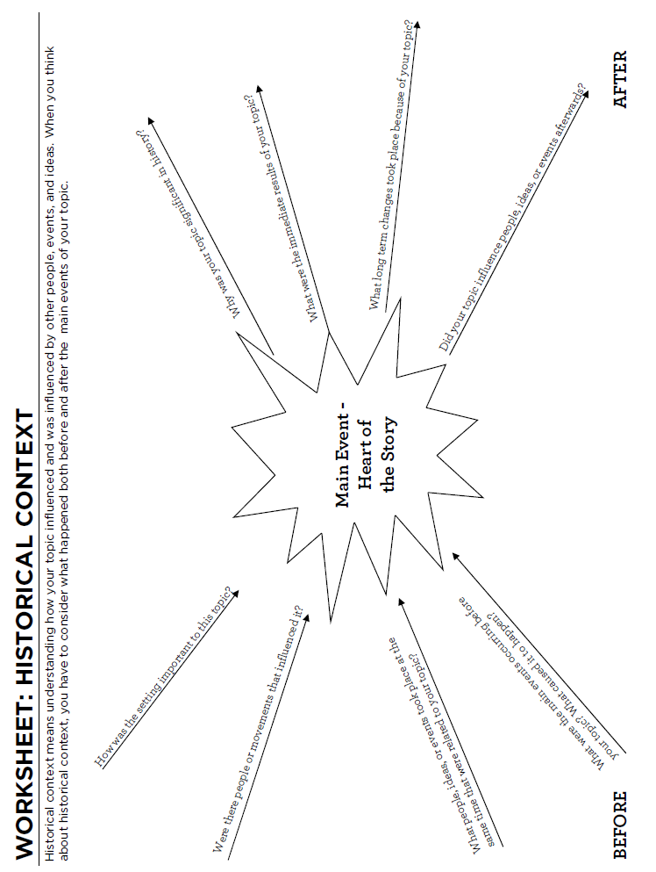
Historical Context
Another important part of your National History Day project is conveying the historical context of your topic.

Historical context means understanding how your topic influenced and was influenced by other people, events, and ideas. When you think about historical context you have to consider both before and after the main events of your topic.

Using the worksheet on the previous page, write 2 paragraphs (at least 10 sentences) about the historical context of your topic.

Historical Significance
Another important part of your National History Day project is conveying the historical significance of your topic.

Historical significance is s the process used to evaluate what was significant about selected events, people, and developments in the past that had an impact towards changing the future.

Topic:

Events or people that are historically significant in relation to this topic:

Brief description of topic:

Significance Criteria In what ways is this event or person historically significant? | In what way does this event or person meet the criteria?
1. Resulting in Change
a) Profundity: How were people affected by the event or person?

b) Quantity: How many people’s lives were affected?

c) Durability: How long lasting were the changes?

2. Revealing
a) How does this event or person shed light on long term issues in history or contemporary life?

b) How does this event or person shed light on emerging issues in history or contemporary life?

Of what larger story or argument might this event or person be a part?

How might the historical significance of this event or person change over time?

Copyright © Centre for the Study of Historical Consciousness, UBC

Revising your Thesis
Revisit your thesis from page 23. Now that you have completed more research has your thesis changed? Is there something else you think you can prove? Rewrite a revised thesis in the space below. Remember that Thesis = Topic + Theme + Impact.

Historical Significance
Another important part of your National History Day project is conveying the historical significance of your topic.

Historical significance is s the process used to evaluate what was significant about selected events, people, and developments in the past that had an impact towards changing the future.

Using the worksheet on the previous two pages, write 2 paragraphs (at least 10 sentences) about the historical significance of your topic.

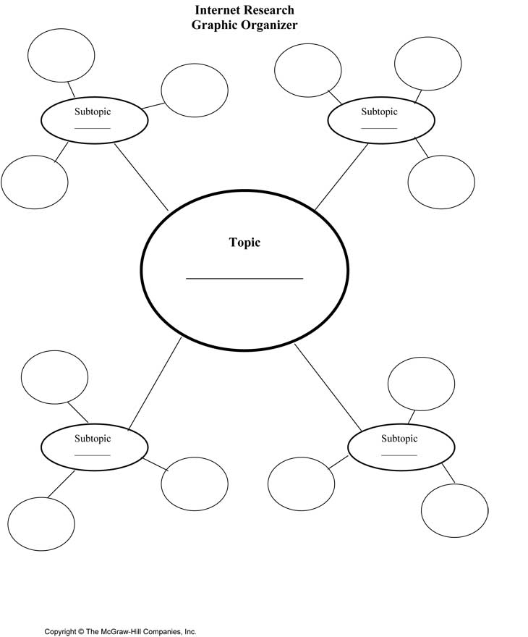
Topic Organizer
In the organizer above write your topic and write four sub-topics that could be explored in your project the bubbles around it. Remember you are trying to prove your thesis statement. Also remember to include the historical significance, historical context, and how your topic relates to the theme.
Topic & Thesis

Making a “Map” for Your Project
Below, please brainstorm some ideas that you would like to get across in your Senior Research Paper. Then, put them in some sort of order to make a “map” of the flow of your paper.
Brainstorm your list, here:

Make a map of the flow of your project, here:

Revising your Thesis AGAIN!
Revisit your thesis from page ______. Now that you have completed your research has your thesis changed? Is there something else you think you can prove? Rewrite a revised thesis in the space below. Remember that Thesis = Topic + Theme + Impact.

Source 1:
1. TYPE OF SOURCE (circle one) Primary or Secondary
2. SOURCE INFORMATION:
Title / Name of Source | Article Title (if needed)
Type (book, interview, etc): | Volume/Edition (if needed)
Author(s)/ Editor(s): | Publisher:
Year Published: | Pages Used:
URL: (www) | When it was electronically published:  Date Used:
*Enter the information above to www.easybib.com and copy and paste into the sources page of your project.
3. FOR ANNOTATION (answer in complete sentences)
What is this source about? How did you use this source? (Don’t just explain about your topic. What is included in this source?)

Describe why it helps you with your topic/project. What does if bring to your research that helps you understand your topic/prove your thesis?

*After your sourcing copied from www.easybib.com you must add the sentences from section 3 above.
Source 2:
1. TYPE OF SOURCE (circle one) Primary or Secondary
2. SOURCE INFORMATION:
Title / Name of Source | Article Title (if needed)
Type (book, interview, etc): | Volume/Edition (if needed)
Author(s)/ Editor(s): | Publisher:
Year Published: | Pages Used:
URL: (www) | When it was electronically published:  Date Used:
*Enter the information above to www.easybib.com and copy and paste into the sources page of your project.
3. FOR ANNOTATION (answer in complete sentences)
What is this source about? How did you use this source? (Don’t just explain about your topic. What is included in this source?)

Describe why it helps you with your topic/project. What does if bring to your research that helps you understand your topic/prove your thesis?

*After your sourcing copied from www.easybib.com you must add the sentences from section 3 above.
Source 3:
1. TYPE OF SOURCE (circle one) Primary or Secondary
2. SOURCE INFORMATION:
Title / Name of Source | Article Title (if needed)
Type (book, interview, etc): | Volume/Edition (if needed)
Author(s)/ Editor(s): | Publisher:
Year Published: | Pages Used:
URL: (www) | When it was electronically published:  Date Used:
*Enter the information above to www.easybib.com and copy and paste into the sources page of your project.
3. FOR ANNOTATION (answer in complete sentences)
What is this source about? How did you use this source? (Don’t just explain about your topic. What is included in this source?)

Describe why it helps you with your topic/project. What does if bring to your research that helps you understand your topic/prove your thesis?

*After your sourcing copied from www.easybib.com you must add the sentences from section 3 above.
Source 4:
1. TYPE OF SOURCE (circle one) Primary or Secondary
2. SOURCE INFORMATION:
Title / Name of Source | Article Title (if needed)
Type (book, interview, etc): | Volume/Edition (if needed)
Author(s)/ Editor(s): | Publisher:
Year Published: | Pages Used:
URL: (www) | When it was electronically published:  Date Used:
*Enter the information above to www.easybib.com and copy and paste into the sources page of your project.
3. FOR ANNOTATION (answer in complete sentences)
What is this source about? How did you use this source? (Don’t just explain about your topic. What is included in this source?)

Describe why it helps you with your topic/project. What does if bring to your research that helps you understand your topic/prove your thesis?

*After your sourcing copied from www.easybib.com you must add the sentences from section 3 above.
Source 5:
1. TYPE OF SOURCE (circle one) Primary or Secondary
2. SOURCE INFORMATION:
Title / Name of Source | Article Title (if needed)
Type (book, interview, etc): | Volume/Edition (if needed)
Author(s)/ Editor(s): | Publisher:
Year Published: | Pages Used:
URL: (www) | When it was electronically published:  Date Used:
*Enter the information above to www.easybib.com and copy and paste into the sources page of your project.
3. FOR ANNOTATION (answer in complete sentences)
What is this source about? How did you use this source? (Don’t just explain about your topic. What is included in this source?)

Describe why it helps you with your topic/project. What does if bring to your research that helps you understand your topic/prove your thesis?

*After your sourcing copied from www.easybib.com you must add the sentences from section 3 above.

Taken from http://library.austincc.edu/help/mla/#citrefs

Parenthetical Documentation
In the MLA format, "parenthetical documentation" is used to briefly identify the sources of information you have borrowed in writing your paper. Parenthetical documentation should be integrated smoothly into the text of your paper, rather than listed separately.
- The general rule is to cite the source right in the text of your paper. If the reader wants to get more information, they go to the Works Cited list at the end of your paper.
If the author's name is mentioned in your writing (this is called a "signal phrase"), you only need to put the page number in parentheses at the end of the sentence. The reader can then consult the list of Works Cited (explained below) at the end of the paper to get the complete citation.
NOTE: Some sources, especially those on the Web, do not give page numbers. The general rule is to use a section number if it is given; otherwise just use the author name or, if no author is given, the first words of the title.
Ross Parke notes that "natural fathers aren't the only ones raising children on their own. As more families split up, social workers note that stepfathers increasingly are being called on to bring up other people's kids" (52).
According to Bernard Farber in Encyclopedia Americana, there is a trend toward waiting to marry and toward postponing the birth of the first child (6).
According to the web site Our Fathers, "Almost 20 percent of fathers ask for child custody after divorce."
- You may decide not to highlight the source of some of your derived information. In such cases, at the end of the sentence enclose in parentheses both the author's last name and the page referred to. The reader can then consult the list of Works Cited at the end of the paper to get the complete citation.
At the turn of the century many men worked long hours, which "entailed their absence from the family for most of the day: that was not a rejection of fatherhood but a necessary element of it" (McKee and O'Brien 54).
Child support payments can be withheld from wages in 45 states (Schorr 33).
- For publications with no author given, you should include the first 2-3 key words from the title and the page number in parentheses.
"Fathers today no longer know who they are or what their wives and children expect from them" ("Fathers Confused" 5), and this increases the likelihood they will abandon their families.
- If possible, you should quote or paraphrase material from the original source, but if you do use material that is within someone else's work, include the abbreviation qtd. in ("quoted in") and then refer to the source where you got the information. Use qtd. in even if it's a paraphrase and not a quote.
Dr. Ann Rudolph contends that fathers who bond with their infant children are more likely to maintain lifelong contact (qtd. in Parke 112).
DO I HAVE TO DOCUMENT EVERYTHING?
One of the hardest parts of documentation is deciding how far to go in documenting sources. If you mention that Los Angeles suffered an earthquake in January 1994, do you have to show where that information came from? No. This is considered "common knowledge," even if you didn't know on your own. This can get tricky. When in doubt it is probably a good idea to include the documentation. Ask a librarian or your instructor for advice on specific situations.

Example of Final Annotated Bibliography
Courtesy of Thomas Reese
You must include an Annotated Bibliography as a part of your project. Below is an example of what it should look like.
"42 Years Later, LGBT Americans Remember the Impact of the Stonewall Riots More than Ever." GLAAD. N.p., 14 Sept. 2011. Web. 07 Dec. 2017. I used this source to better explain the short-term impact and the events that lead to riots across New York. This source helped me better understand the short term and long term impact that these riots had on the nation.
"Digital History." Digital History. N.p., n.d. Web. 05 Jan. 2017. I used this source to gain background knowledge on the laws that were in place to prevent homosexual lifestyles. This helped me understand the negative opinions that the gay community had with the police force.
Pamela Skillings Manhattan, NY Expert. "How the Riots at NYC's Stonewall Inn Shaped the History of Gay Rights." About.com Travel. N.p., 28 May 2016. Web. 02 Dec. 2017. I used this source to help me understand where the event took place and the bar that it took place in. This helped me better understand how common raids were in gay bars.
"The Stonewall Riot." History.com. A&E Television Networks, n.d. Web. 02 Dec. 2017. I used this source to gain background information to help me decide on the topic and I used this as key information in my website. This helped me better understand my topic because it made me aware of how fed up the members of the LGBT community were with the police.
"The Stonewall Riots – 1969." Socialist Alternative. N.p., n.d. Web. 23 Dec. 2017. I used this source as a reference to what started the riots and the speculation that occurred over it. This source helped me better understand the immediate impact of the riots as it discusses the Gay Liberation group that formed nearly a week after the riots.

NHD Project Grading Rubric

Name of Participant(s): _________________________________________________________
1-4-Needs
8-10-Excellent 5-7-Good Improvement Score
Thesis statement | Makes a strong claim and takes a position on topic | Includes a thesis but does not take a clear position | Thesis statement was unclear or not included
Entry is historically accurate | No mistakes in historical accuracy | Entry includes 3 or fewer mistakes in historical accuracy | More than 3 historical inaccuracies
Historical context | Places the topic into context and includes information about what else is going on during the time period | Includes time and place but doesn’t include info about what else is happening during that time period | Is unclear about the time and place
Connection to theme | Several connections are shown to the theme of Taking a Stand in History. | Makes at least one clear connection to the theme of Taking a Stand in History. | No clear connection to the theme of Taking a Stand in History is made
Historical Significance | The historical impact of the topic is clear | The historical impact of the topic is mentioned but not well-defined | The historical impact of the topic is not made clear
Written material  *If your written material is plagiarized you will received a 0 on project | Original, clear, appropriate and organized with few or no mechanical errors | Original and appropriate but some problems with clarity, organization or mechanics | Unclear or disorganized, many mechanical errors
Visual appearance  (websites, exhibits, video) | Has visual impact, organized, and neat | Is organized but there are problems with neatness and/or lack of visual impact | Lack of organization and/or problems with neatness and lack of visual impact
Parenthetical Documentation | Use of correct parenthetical citations within the body of the paper are clear and correct. | Use of parenthetical citations are attempted, but not done correctly. | Evidence of research is in the paper, but no citations were completed OR no research is evident
Annotated Bibliography | Annotated bibliography contains 5 sources and is completed correctly. | Annotated bibliography contains at least 3 sources and is completed correctly | Annotated bibliography contains less than 3 sources and is completed correctly
Met due date | Project was turned in on time. | Project was turned in 1-2 days late. | Project was turned in 3 or more days after date.
Total:

Comments:

